

Progress Report

SIDBI – PMU J&K

**Activities Performed by PMU during Dec-22 - Jan 23**

* PMU is working on the base line report of MSME units in the UT of Jammu and Kashmir.
* PMUfacilitated the awareness programme at MSME EXPO organised by MSME DFO Jammu Kashmir about SIDBI Schemes and its Initiative on MSME sector in J&K.
* PMU is working on creating linkages for CGTMSE, SCDF with various departments like industries and Commerce and Department of Toursim.
* Follow up visits:

1. In the Meeting with the Secretary Industries & Commerce (Mrs Smita Sethi) UT of J&K, it was highlighted that she had proposed the requirement of 2000 crore when she was as MD SIDCO/SICOP. In the follow up, a meeting with the Principal Secretary will conducting highlighting all these parameters.
2. In the Meeting with the Principal Secretary I&C Shri Prashant Goyal, IAS, Director Finance and Secretary I&C J&K. The Meeting was also attended by Director Finance Shri Suresh Koul & Secretary I&C J&K.

* The follow up meetings with the Principal Secretary, it has been requested to expedite the process of identifying projects for SCDF.
* A New meeting has been called with SIDBI and GT officials with The PS sir in order the to facilitate with one Technical Staff as PMU for making the Action Plan/Road Map of Infrastructure Development of new estates where allotments has been done so that more and more funds can be routed through SCDF.
* One CGTMSE MOU has been submitted to the Secretary I&C and Secretary I&C has discussed the same with PS sir. Further discussion is on track.
* The Secretary I&C has submitted a request mail to CGM Sir for extending Present PMU Scope and providing technical assistance through PMU for Development of a holistic plan/road map to develop new Industrial Estates and maintenance of the existing Industrial Estates. A new meeting has been scheduled in the last days of January 2023 for the said activity.

1. In the Meeting with Secretary to Government (Tourism) Shri Sarmad Hafeez, IAS in UT of J&K, it was discussed various pending issues like first ever SCDF Committee Meeting after its formation.

* PMU along with SIDBI XBO-Jammu division gave presentation on SIDBI offerings at MSME-DFO EXPO at Jammu HAAT Jammu on 21-Dec-22 and 22-Dec-22.
* PMU also attended KVIC, KVIB and DIC meeting along with SIDBI XBO at Civil Secretariat jammu.
* As a part of immersion program and stakeholder consultation, the team met the Major Industry associations in J&K, like in President of Small-Scale industries Association Bari Brahmana, Industrial Estate Lassipora, Khatua etc for introduction of SIDBI and its Schemes.
* PMU met with new MD SIDCO and SICOP and make him aware about all the SIDBI schemes and asked for help if any new leads come to the office. Have discussed in details about the green financing schemes and requested him to inform us if there are any new awareness programs organized by the office.
* PMU team met with the Directorate of Industries and commerce and update her about the work done by SIDBI and its PMU in the UT of Jammu and Kashmir. We also requested her to intimate all the DICs in the UT of Jammu and Kashmir to include SIDBI in all the awareness campaigns in all the parts of Jammu and Kashmir. The meeting has shown positive results.
* PMU is also working on Baseline Report of MSME across J&K and will submit the report at earliest to Principal Secretary of I&C of J&K UT.
* PMUalso visited major upcoming and existed Industrial Estates Barsoo Ganderbal, Samba Phase III, with the team of JK-SICOP.
* PMU along with SIDBI XBO went to two RBI training Programs. First for Lead bank officers at all the districts of Jammu Kashmir and second for new bankers and gave presentation on Udyam Registration Programme for MSMEs.
* PMU also facilitating SIDBI for MOU with Central University Kashmir towards education to entrepreneurship on Skill to entrepreneurship module under Mission Swavalamban.
* PMU organized a capacity building Programme for Artisans towards onboarding products on e-platforms like Amazon, Flipkart, GEM etc

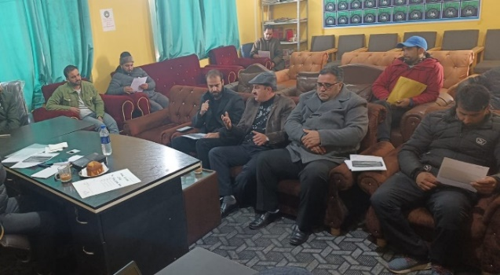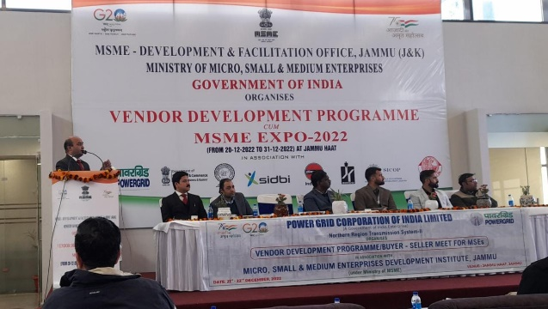

|  |  |
| --- | --- |
| **MSME EXPO** | **IE IGC Lassipora** |

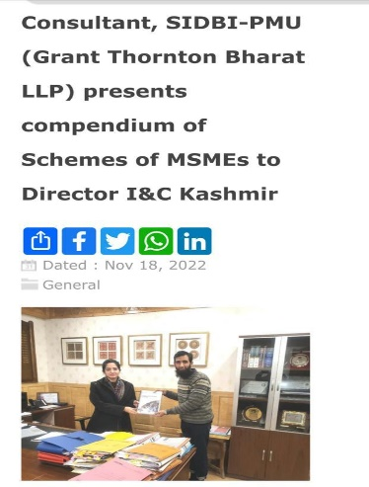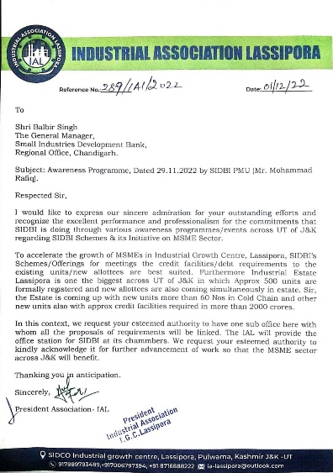

**Contact us**

To know more, please visit [**www.grantthornton.in**](http://www.grantthornton.in/) or contact any of our offices as mentioned below:

|  |  |  |  |  |
| --- | --- | --- | --- | --- |
| **NEW DELHI**  National Office, Outer Circle, L 41, Connaught Circus, New Delhi - 110001 T +91 11 4278 7070 | **NEW DELHI**  6th Floor, Worldmark 2, Aerocity,  New Delhi - 110037 T +91 11 4952 7400 | **AHMEDABAD**  7th Floor, Heritage Chambers,  Nr Azad Society, Nehru Nagar, Ahmedabad - 380015 | **BENGALURU**  5th Floor, 65/2, Block A, Bagmane Tridib, Bagmane Tech Park, CV Raman Nagar, Bengaluru - 560093  T+91 80 4243 0700 | **CHANDIGARH**  B-406A, 4th Floor, L&T Elante Office Building, Industrial Area Phase I, Chandigarh - 160002  T +91 172 4338 000 |
| **CHENNAI**  7th Floor, Prestige Polygon,  471, Anna Salai, Teynampet, Chennai - 600018  T +91 44 4294 0000 | **DEHRADUN**  Suite No 2211, 2nd Floor, Building 2000, Michigan Avenue, Doon Express Business Park,  Subhash Nagar, Dehradun - 248002  T +91 135 2646 500 | **GURGAON**  21st Floor, DLF Square, Jacaranda Marg, DLF Phase II,  Gurgaon - 122002  T +91 124 462 8000 | **HYDERABAD**  7th Floor, Block III, White House,  Kundan Bagh, Begumpet, Hyderabad - 500016  T +91 40 6630 8200 | **KOCH**I  6th Floor, Modayil Centre Point, Warriam Road Junction, MG Road Kochi - 682016  T +91 484 406 4541 |
| **KOLKATA**  10C Hungerford Street, 5th Floor,  Kolkata - 700017  T +91 33 4050 8000 | **MUMBAI**  11th Floor, Tower II,  One International Center, SB Marg Prabhadevi (W), Mumbai - 400013  T +91 22 6626 2600 | **MUMBAI**  Kaledonia, 1st Floor, C Wing, (Opposite J&J Office),  Sahar Road, Andheri East,  Mumbai - 400 069 | **NOIDA**  Plot No 19A, 2nd Floor, Sector - 16A,  Noida - 201301  T +91 120 485 5900 | **PUNE**  3rd Floor, Unit No 309- 312, West Wing, Nyati Unitree, Nagar Road, Yerwada  Pune - 411006  T +91 20 6744 8800 |

For more information or for any queries, write to us at [**contact@in.gt.com**](mailto:contact@in.gt.com)

|  |  |
| --- | --- |
| Twitter-outline | **Follow us @GrantThorntonIN** |

**Small Industries Development Bank of India (SIDBI),** established under an Act of Parliament in 1990, acts as the Principal Financial Institution for Promotion, Financing and Development of the Micro, Small and Medium Enterprise (MSME) sector as well as for co-ordination of functions of institutions engaged in similar activities. In the context of the changing MSME lending landscape, the role of SIDBI has been realigned through adoption of SIDBI Vision 2.0 which envisages an integrated credit and development support role of the Bank by being a thought leader, adopting a credit-plus approach, creating a multiplier effect and serving as an aggregator in MSME space.





***Disclaime****r: This document is prepared under SIDBI intervention in which Grant Thornton Bharat LLP is the implementing agency. The document users/third parties shall verify the facts and figures at their end and shall be solely liable for any action taken by it based on this document. SIDBI, its directors, employees or any office shall not be liable for loss of whatsoever nature arising by using the content of this do*